Updating a Garmin GPS

Use this to update the Garmin 18x pc gps receivers to firmware version 4.20. This this version has a fix for the April 6th 2019 rollover issue.

- Load Garmin Installation instructions if you prefer to follow that, otherwise continue below.
.Garmin Instructions: https://www8.garmin.com/support/download_details.jsp?id=4055#Instruct

- -Download 4.20 update (http://download.garmin.com/software/GPS18xPC_LVC_420.exe)

- -Extract "GPS18xPC_LVC_420.exe" by running it. Select "C:\Garmin" as location (default option).
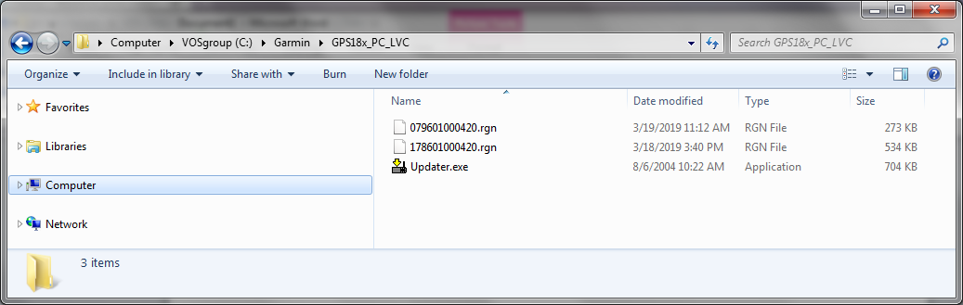
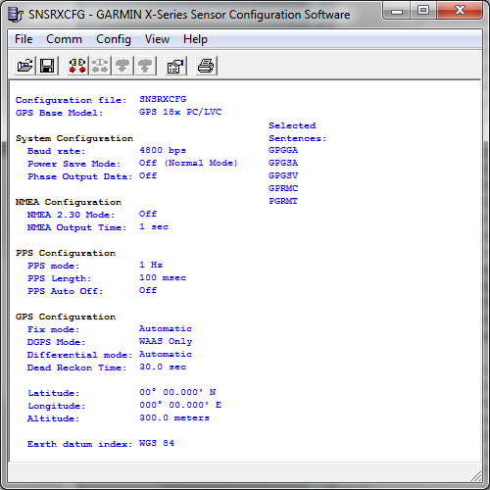
- - Start the SNSRXCFG_200 program. select option GPS 18x PC and click OK
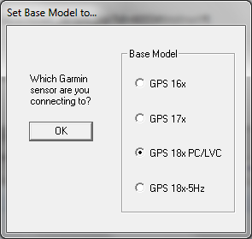

- -From the "Comm" – “Setup” menu select the appropriate serial port, set a manual baud rate of 4800, and click OK.
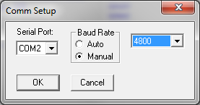
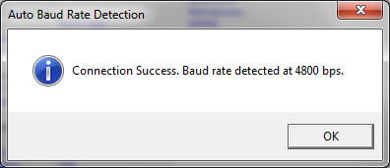
If successful, you will get this:

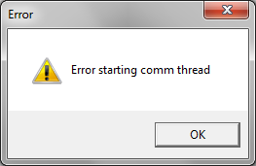
If there is an error, make sure the GPS is powered and working.

- -From the "Comm" menu select "Connect".
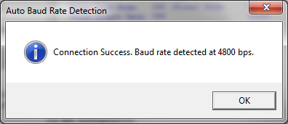

- -From the "View" menu select “NMEA Transmitted Sentences” and check that NMEA sentences are streaming.
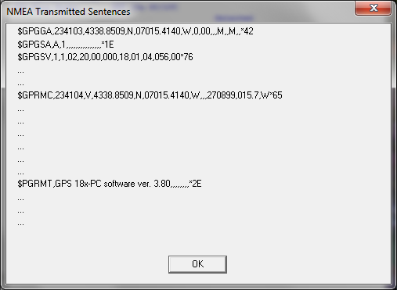

- -From the “Config” menu select "Update Software".
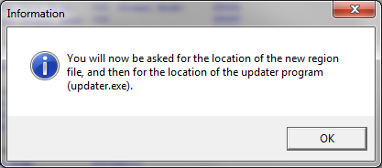

- -Select the following file "079601000420.rgn" (located in C:\Garmin)

- -When asked to update program, select the "Updater.exe" program that was
just extracted in C:\Garmin. At this point SNSRXCFG_200 should start Updater.exe
if it doesn't, try one of these solution:
- close SNSRXCFG_200 and run Updater.exe
- Keep SNSRXCFG_200 running and run Updater.exe in addition
(We had to do this with some Windows 10 computers)

- -Now select correct serial port and set a baud rate of "115200"
This might take a while.
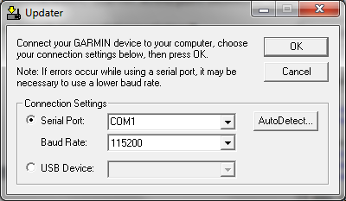

A successful connection should show:
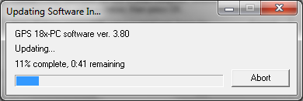

If an error occurs, restart GPS (cycle power) and go back to step 8
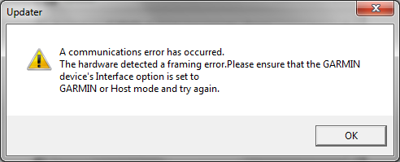

- Once the update is complete, cycle the power to the unit (disconnect and reconnect it) in order to reboot it.
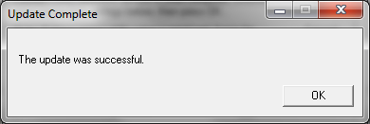

- -In SNSRXCFG.exe, reconnect to the device (“Comm”-“Connect”) if necessary, and once successful, select menu “View”-“NMEA Transmitted Sentences” and make sure NMEA sentences are streaming. Also check the version of the software is now 4.20 and that the date (maybe in the $GPRMC NMEA string) is correct. It might take a couple power cycle to correct. Alternatively, open a terminal program like Hyperterminal, putty, minicom etc.. Set the connection to 4800,8,N,1
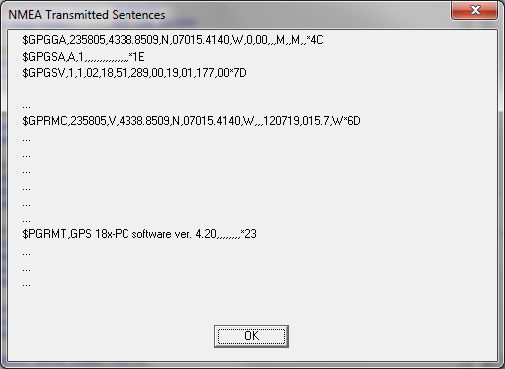

- .To Select NMEA strings to output, go to menu “Config”- “NMEA Sentence Selections”
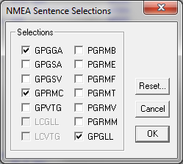
- Select the desired strings to output and click OK.

- Save the configuration by going to the menu “Config”-“Send Configuration to GPS”
No need to save the configuration when exiting the software.

